Alberto Parreira Almada

WDD 230

Temple Inn & Suites Bountiful

Website Planning Document

**Purpose**

The purpose of this document is to present the website planning for the unity of Temple Inn & Suites, located at Bountiful/UT.

**Logo**

To identify the customers of hotel brands and to this unity is presenting the logo.



**Site purpose**

This site aims to connect members of The Chuch of Jesus Christ of Latter-day Saints, who are visiting the Bountiful Temple Area, and vicinity, to promote a singular hotel experience, for all family members, also the opportunity for a full-time missionary to stay in a place like home, far from home.

**Site domain name**

The domain proposed is [www.innsuitesbountiful.com](http://www.innsuitesbountiful.com) .

**Target Audience**

The target audience of this website is the public who is visiting the Bountiful Temple/UT, providing special services like infant care center & recreation, shuttle service for temple sessions, and for the full-time missionary the possibility to stay in a clean, safe and affordable place during the mission.

**Site map**

The website will be 5 pages.

**Home page**

Showing the logo, a menu bar, and the link for hotel social media, also shows some Boutinful Temple pictures and a button to make a room reservation (on another page).

The home page shows weather forecast conditions and weather alerts.

**Temple page**

This page has some Temple informations, including details about Bountiful Temple, and the other 4 Temples.

**Services Information page**

This page give’s your customers, information about hotel services for weddings and catering, food & beverage services, infant care center & recreation activities, shuttle Temple services, and the special conditions for full-time missionaries.

**Reservation page**

The reservation page content is a digital form, that the customer fills to make a room reservation, showing some room pics.

**Contact Us page**

The contact page has some hotel information and a digital form for the customer fills for the client who needs clarification or has some question about the hotel services.

**Typography**

The site will use the font Merriweather-Sans, and Open-Sans.

The size fonts: 30px, 24px, 18px, 16px.

This option of fonts makes the website more readable.

**Color Scheme**

We will work on this project with the colors in this pallet.

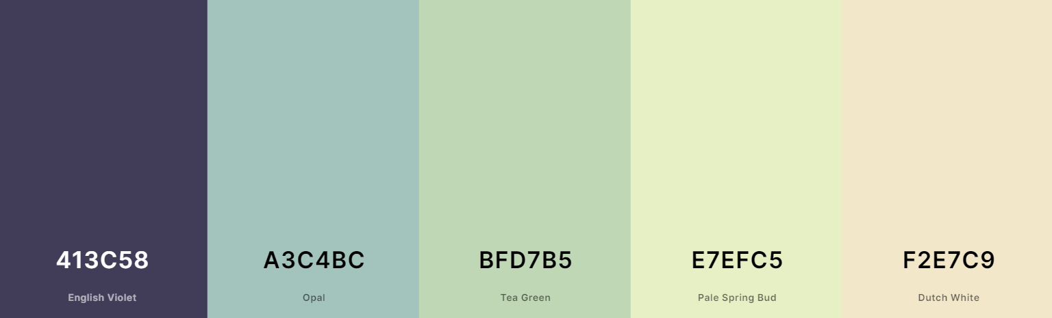

The font color is black and white to contrast with the background.

**The website wireframes**

**The Home page**

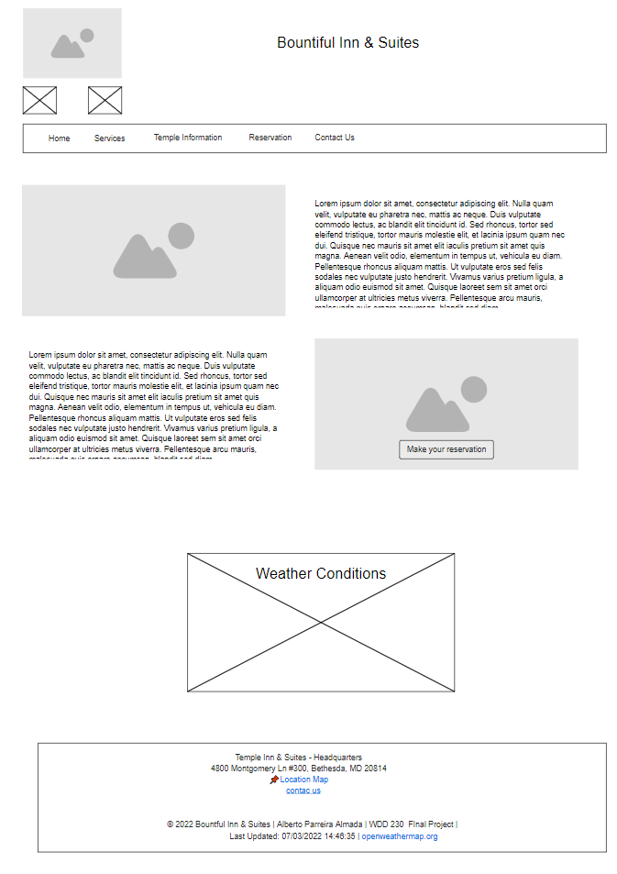

**The Temple page**

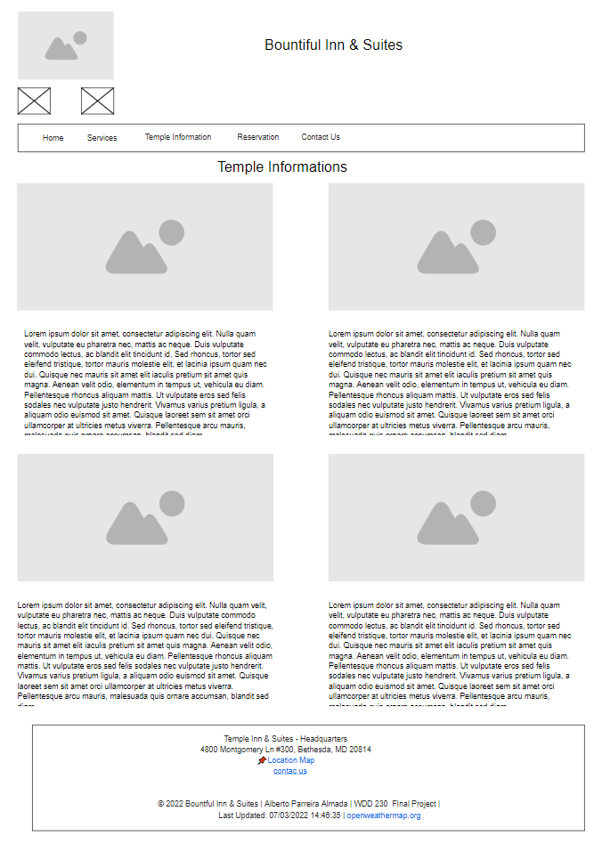

**The Services page**

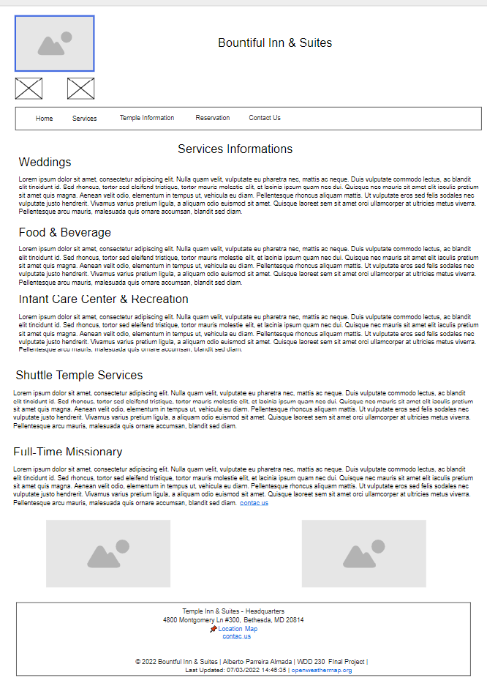

**The Reservation page**

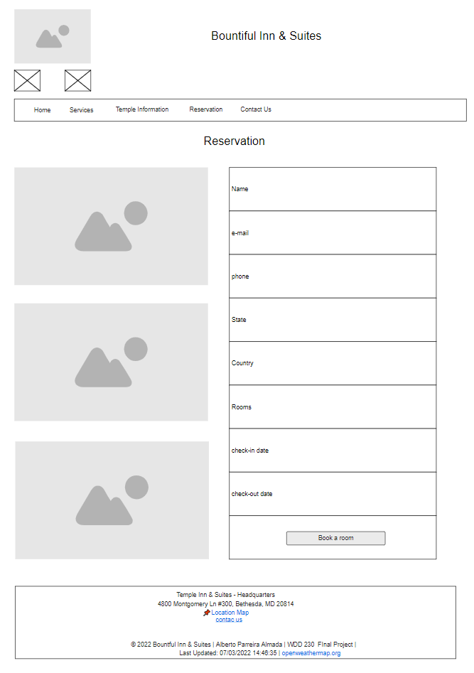

**The Contact Us page**

